Coronavirus disease 2019 (COVID-19)
Situation Report – 99

Data as received by WHO from national authorities by 10:00 CEST, 28 April 2020

HIGHLIGHTS

- WHO has published the ‘R&D Blueprint: COVID-19 Experimental Treatments’, which lists drug and non-drug experimental treatments for COVID-19. This can be found here.

- WHO has called on countries to ensure that usual immunization is maintained wherever possible and surveillance for vaccine-preventable diseases is not disrupted during the ongoing pandemic. The WHO Regional Office for Europe explores this in an article available here.

- WHO Director-General Dr. Tedros, in his regular media briefing yesterday, highlighted “As lockdowns in Europe ease with declining numbers of new cases, we continue to urge countries to find, isolate, test and treat all cases of COVID-19 and trace every contact, to ensure these declining trends continue”. More information is available here.

- WHO continues to source millions of dollars of medical equipment and supplies to help Member States access global markets, which are overwhelmed by unprecedented demand. WHO is also supporting design and installation of COVID- 19 treatment centres in a number of countries. For more, see ‘Subject in Focus’ below.

SITUATION IN NUMBERS
total (new cases in last 24 hours)

Globally
2 954 222 confirmed (76 026)
202 597 deaths (3932)

European Region
1 386 693 confirmed (27 313)
126 429 deaths (1904)

Region of the Americas
1 179 607 confirmed (39 087)
60 211 deaths (1722)

Eastern Mediterranean Region
171 238 confirmed (5305)
7148 deaths (157)

Western Pacific Region
145 385 confirmed (1264)
5998 deaths (40)

South-East Asia Region
48 348 confirmed (2288)
1917 deaths (93)

African Region
22 239 confirmed (769)
881 deaths (16)

WHO RISK ASSESSMENT
Global Level Very High

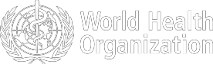

Figure 1. Countries, territories or areas with reported confirmed cases of COVID-19, 28 April 2020
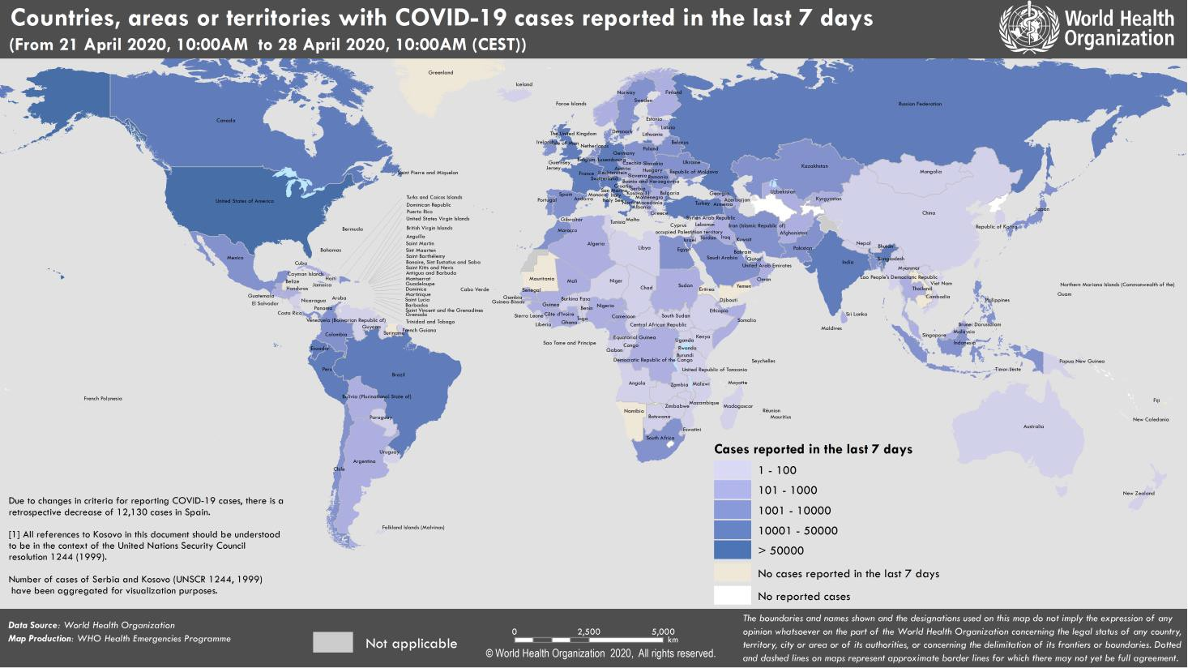

SUBJECT IN FOCUS: Operations Support and Logistics (OSL) update

Sourcing Supplies – Progress Update

WHO and partners continue to work with suppliers to secure commitments for supplies needed for the COVID-19 response in countries with limited means to access markets for personal protective equipment, diagnostic testing supplies and clinical care equipment.

A diagnostic purchasing consortium, established by WHO to negotiate with manufacturers to address market shortages of diagnostic tests and supplies, has secured commitment for five million tests to be procured over the next four weeks. WHO continues to look for suppliers who can provide sample collection kits to increase overall procurement stocks.

Collective UN efforts to source extremely limited supplies of clinical equipment are ongoing. WHO and consortium partners have conducted market mapping activities to identify supply sources for oxygen concentrators, ventilators, and other essential equipment for COVID-19 treatment centers. To date, approximately US$400 million in clinical care equipment has been identified from oxygen production, biomedical equipment and accessories manufacturers.

Discussions with private sector partners indicate manufacturers are generally in favour of the COVID-19 Supply Chain approach to sourcing and allocating supplies. This should bring clarity and transparency to requests for critical supplies that manufacturers are receiving from around the world.

Sourcing activities for personal protective equipment are ongoing. The first batch of purchases are expected to be placed for 75 million masks, 50 million respirators, 28 million gloves and 10 million face shields.

Discussions are ongoing with the Jack Ma Foundation for an additional provision of 100 million surgical masks and one million respirators.

Technical support for COVID-19 treatment centres

WHO is supporting Italy’s Bologna and Puglia provinces, helping to design and install COVID-19 treatment centres in these provinces’ hospitals.

In Nigeria, WHO has provided technical guidance for a proposed self-quarantine facility in an internally displaced persons (IDP) camp run by the International Organization for Migration (IOM).

WHO has also provided support for the installation of COVID-19 treatment facilities in Burkina Faso, Côte d’Ivoire, Senegal, São Tomé and Príncipe and Australia.
SURVEILLANCE
Reporting Country/ Territory/Area† | Total  ‡  cases |  | New confirmed cases | Total deaths | New deaths | Transmission classification§ | Days since last reported case
Western Pacific Region
China |  | 84347 | 6 | 4643 | 0 | Clusters of cases | 0
Singapore |  | 14423 | 799 | 14 | 2 | Clusters of cases | 0
Japan |  | 13576 | 191 | 376 | 25 | Clusters of cases | 0
Republic of Korea |  | 10752 | 14 | 244 | 1 | Clusters of cases | 0
Philippines |  | 7777 | 198 | 511 | 10 | Clusters of cases | 0
Australia |  | 6725 | 12 | 84 | 1 | Clusters of cases | 0
Malaysia |  | 5820 | 40 | 99 | 1 | Clusters of cases | 0
New Zealand |  | 1124 | 2 | 19 | 0 | Clusters of cases | 0
Viet Nam |  | 270 | 0 | 0 | 0 | Clusters of cases | 1
Brunei Darussalam |  | 138 | 0 | 1 | 0 | Sporadic cases | 8
Cambodia |  | 122 | 0 | 0 | 0 | Sporadic cases | 16
Mongolia |  | 38 | 0 | 0 | 0 | Sporadic cases | 1
Lao People's Democratic Republic |  | 19 | 0 | 0 | 0 | Sporadic cases | 15
Fiji |  | 18 | 0 | 0 | 0 | Sporadic cases | 7
Papua New Guinea |  | 8 | 0 | 0 | 0 | Sporadic cases | 5
Territories**
Guam |  | 138 | 1 | 5 | 0 | Clusters of cases | 0
French Polynesia |  | 58 | 1 | 0 | 0 | Sporadic cases | 0
New Caledonia |  | 18 | 0 | 0 | 0 | Sporadic cases | 25
Northern Mariana Islands (Commonwealth of the) |  | 14 | 0 | 2 | 0 | Pending | 10
European Region
Spain |  | 209465 | 1831 | 23190 | 0 | Pending | 0
Italy |  | 199414 | 1739 | 26977 | 333 | Community transmission | 0
The United Kingdom |  | 157153 | 4309 | 21092 | 360 | Community transmission | 0
Germany |  | 156337 | 1144 | 5913 | 163 | Community transmission | 0
France |  | 127008 | 3729 | 23261 | 440 | Community transmission | 0
Turkey |  | 112261 | 2131 | 2900 | 95 | Community transmission | 0
Russian Federation |  | 93558 | 6411 | 867 | 73 | Clusters of cases | 0
Belgium |  | 46687 | 553 | 7207 | 113 | Community transmission | 0
Netherlands |  | 38245 | 400 | 4518 | 43 | Community transmission | 0

Table 1. Countries, territories or areas with reported laboratory-confirmed COVID-19 cases and deaths, by WHO region.* Data as of 28 April 2020

confirmed

Switzerland | 29081 | 103 | 1352 | 16 | Community transmission | 0
Portugal | 24027 | 163 | 928 | 25 | Pending | 0
Ireland | 19648 | 386 | 1102 | 15 | Community transmission | 0
Sweden | 18926 | 286 | 2274 | 80 | Community transmission | 0
Israel | 15466 | 68 | 202 | 3 | Pending | 0
Austria | 15256 | 67 | 549 | 7 | Community transmission | 0
Belarus | 12208 | 1745 | 79 | 7 | Clusters of cases | 0
Poland | 11902 | 285 | 562 | 27 | Community transmission | 0
Romania | 11339 | 303 | 631 | 23 | Community transmission | 0
Ukraine | 9410 | 401 | 239 | 19 | Community transmission | 0
Denmark | 8698 | 123 | 427 | 5 | Pending | 0
Serbia | 8275 | 233 | 162 | 6 | Pending | 0
Norway | 7533 | 28 | 193 | 0 | Pending | 0
Czechia | 7449 | 45 | 223 | 2 | Community transmission | 0
Finland | 4695 | 119 | 193 | 3 | Pending | 0
Luxembourg | 3729 | 6 | 88 | 0 | Pending | 0
Republic of Moldova | 3481 | 73 | 103 | 7 | Pending | 0
Kazakhstan | 2982 | 191 | 25 | 0 | Pending | 0
Hungary | 2649 | 66 | 291 | 11 | Clusters of cases | 0
Greece | 2534 | 28 | 136 | 6 | Community transmission | 0
Croatia | 2039 | 9 | 59 | 4 | Community transmission | 0
Uzbekistan | 1924 | 37 | 8 | 0 | Clusters of cases | 0
Armenia | 1867 | 59 | 30 | 1 | Clusters of cases | 0
Iceland | 1792 | 0 | 10 | 0 | Community transmission | 1
Azerbaijan | 1678 | 33 | 22 | 1 | Clusters of cases | 0
Estonia | 1647 | 4 | 50 | 1 | Pending | 0
Bosnia and Herzegovina | 1564 | 48 | 60 | 2 | Community transmission | 0
Lithuania | 1449 | 0 | 41 | 0 | Community transmission | 1
Slovenia | 1407 | 0 | 83 | 1 | Community transmission | 1
North Macedonia | 1399 | 13 | 65 | 4 | Clusters of cases | 0
Slovakia | 1381 | 2 | 18 | 0 | Clusters of cases | 0
Bulgaria | 1363 | 63 | 58 | 2 | Pending | 0
Cyprus | 822 | 5 | 20 | 3 | Clusters of cases | 0
Latvia | 818 | 6 | 13 | 1 | Community transmission | 0
Andorra | 748 | 8 | 40 | 0 | Community transmission | 0
Albania | 736 | 10 | 28 | 0 | Clusters of cases | 0

Kyrgyzstan | 708 | 13 | 8 | 0 | Pending | 0
San Marino | 538 | 0 | 41 | 0 | Community transmission | 1
Georgia | 511 | 15 | 6 | 0 | Community transmission | 0
Malta | 450 | 2 | 4 | 0 | Pending | 0
Montenegro | 321 | 0 | 7 | 0 | Clusters of cases | 1
Liechtenstein | 83 | 0 | 1 | 0 | Pending | 1
Monaco | 68 | 0 | 1 | 0 | Sporadic cases | 14
Holy See | 9 | 0 | 0 | 0 | Sporadic cases | 7
Territories**
Kosovo[1] | 780 | 17 | 22 | 1 | Community transmission | 0
Isle of Man | 308 | 0 | 18 | 0 | Pending | 1
Jersey | 281 | 1 | 19 | 0 | Pending | 0
Guernsey | 247 | 2 | 13 | 1 | Community transmission | 0
Faroe Islands | 187 | 0 | 0 | 0 | Pending | 4
Gibraltar | 141 | 0 | 0 | 0 | Clusters of cases | 1
Greenland | 11 | 0 | 0 | 0 | Pending | 22
South-East Asia Region
India | 29435 | 1543 | 934 | 62 | Clusters of cases | 0
Indonesia | 9096 | 214 | 765 | 22 | Community transmission | 0
Bangladesh | 5913 | 497 | 152 | 7 | Pending | 0
Thailand | 2938 | 7 | 54 | 2 | Pending | 0
Sri Lanka | 523 | 0 | 7 | 0 | Clusters of cases | 1
Maldives | 214 | 26 | 0 | 0 | Clusters of cases | 0
Myanmar | 146 | 0 | 5 | 0 | Clusters of cases | 1
Nepal | 52 | 1 | 0 | 0 | Sporadic cases | 0
Timor-Leste | 24 | 0 | 0 | 0 | Clusters of cases | 4
Bhutan | 7 | 0 | 0 | 0 | Sporadic cases | 5
Eastern Mediterranean Region
Iran (Islamic Republic of) | 91472 | 991 | 5806 | 96 | Community transmission | 0
Saudi Arabia | 18811 | 1289 | 144 | 5 | Clusters of cases | 0
Pakistan | 13915 | 587 | 292 | 11 | Clusters of cases | 0
Qatar | 11244 | 957 | 10 | 0 | Pending | 0
United Arab Emirates | 10839 | 490 | 82 | 6 | Pending | 0
Egypt | 4782 | 248 | 337 | 20 | Clusters of cases | 0
Morocco | 4120 | 55 | 162 | 1 | Clusters of cases | 0
Kuwait | 3288 | 213 | 22 | 2 | Clusters of cases | 0
Bahrain | 2723 | 76 | 8 | 0 | Clusters of cases | 0
Oman | 2131 | 82 | 10 | 0 | Clusters of cases | 0
Iraq | 1847 | 27 | 88 | 1 | Clusters of cases | 0
Afghanistan | 1703 | 172 | 60 | 10 | Clusters of cases | 0
Djibouti | 1035 | 12 | 2 | 0 | Clusters of cases | 0
Tunisia | 967 | 18 | 39 | 1 | Community transmission | 0
Lebanon | 710 | 3 | 24 | 0 | Clusters of cases | 0

Somalia | 480 | 44 | 26 | 3 | Sporadic cases | 0
Jordan | 449 | 2 | 7 | 0 | Clusters of cases | 0
Sudan | 275 | 38 | 22 | 1 | Sporadic cases | 0
Libya | 61 | 0 | 2 | 0 | Clusters of cases | 1
Syrian Arab Republic | 43 | 1 | 3 | 0 | Community transmission | 0
Yemen | 1 | 0 | 0 | 0 | Pending | 17
Territories**
occupied Palestinian territory | 342 | 0 | 2 | 0 | Clusters of cases | 1
Region of the Americas
United States of America | 960916 | 29218 | 49170 | 1190 | Community transmission | 0
Brazil | 61888 | 3379 | 4205 | 189 | Community transmission | 0
Canada | 47316 | 1538 | 2617 | 128 | Community transmission | 0
Peru | 27517 | 2186 | 728 | 28 | Community transmission | 0
Ecuador | 23240 | 521 | 663 | 87 | Community transmission | 0
Mexico | 14677 | 835 | 1351 | 46 | Community transmission | 0
Chile | 13813 | 482 | 198 | 9 | Community transmission | 0
Dominican Republic | 6293 | 158 | 282 | 4 | Community transmission | 0
Panama | 5779 | 241 | 165 | 6 | Community transmission | 0
Colombia | 5379 | 237 | 244 | 11 | Community transmission | 0
Argentina | 3892 | 54 | 192 | 13 | Community transmission | 0
Cuba | 1389 | 20 | 56 | 2 | Clusters of cases | 0
Bolivia (Plurinational State of) | 950 | 84 | 50 | 4 | Clusters of cases | 0
Costa Rica | 695 | 2 | 6 | 0 | Clusters of cases | 0
Honduras | 661 | 34 | 61 | 2 | Clusters of cases | 0
Uruguay | 606 | 10 | 15 | 1 | Clusters of cases | 0
Guatemala | 500 | 27 | 15 | 0 | Clusters of cases | 0
Venezuela (Bolivarian Republic of) | 325 | 2 | 10 | 0 | Clusters of cases | 0
El Salvador | 323 | 25 | 8 | 0 | Clusters of cases | 0
Jamaica | 305 | 0 | 7 | 0 | Clusters of cases | 1
Paraguay | 228 | 0 | 9 | 0 | Community transmission | 1
Trinidad and Tobago | 116 | 1 | 8 | 0 | Sporadic cases | 0
Bahamas | 80 | 2 | 11 | 0 | Clusters of cases | 0
Barbados | 79 | 0 | 6 | 0 | Clusters of cases | 1
Guyana | 74 | 0 | 8 | 0 | Clusters of cases | 1
Haiti | 74 | 2 | 6 | 0 | Clusters of cases | 0
Antigua and Barbuda | 24 | 0 | 3 | 0 | Clusters of cases | 5
Belize | 18 | 0 | 2 | 0 | Sporadic cases | 13

Grenada | 18 | 0 | 0 | 0 | Clusters of cases | 1
Dominica | 16 | 0 | 0 | 0 | Clusters of cases | 17
Saint Kitts and Nevis | 15 | 0 | 0 | 0 | Sporadic cases | 7
Saint Lucia | 15 | 0 | 0 | 0 | Sporadic cases | 16
Saint Vincent and the Grenadines | 15 | 1 | 0 | 0 | Sporadic cases | 0
Nicaragua | 13 | 0 | 3 | 0 | Pending | 1
Suriname | 10 | 0 | 1 | 0 | Sporadic cases | 24
Territories**
Puerto Rico | 1389 | 18 | 53 | 0 | Clusters of cases | 0
Martinique | 175 | 0 | 14 | 0 | Clusters of cases | 1
Guadeloupe | 149 | 0 | 10 | 0 | Clusters of cases | 1
French Guiana | 111 | 2 | 1 | 0 | Clusters of cases | 0
Bermuda | 109 | 0 | 6 | 1 | Clusters of cases | 1
Aruba | 100 | 0 | 2 | 0 | Clusters of cases | 5
Sint Maarten | 74 | 0 | 13 | 0 | Clusters of cases | 1
Cayman Islands | 70 | 0 | 1 | 0 | Clusters of cases | 1
United States Virgin Islands | 59 | 4 | 4 | 1 | Clusters of cases | 0
Saint Martin | 38 | 0 | 3 | 0 | Sporadic cases | 5
Curaçao | 16 | 2 | 1 | 0 | Sporadic cases | 0
Falkland Islands (Malvinas) | 13 | 0 | 0 | 0 | Clusters of cases | 1
Turks and Caicos Islands | 12 | 1 | 1 | 0 | Sporadic cases | 0
Montserrat | 11 | 0 | 1 | 0 | Sporadic cases | 14
Bonaire, Sint Eustatius and Saba | 6 | 1 | 0 | 0 | Sporadic cases | 0
British Virgin Islands | 6 | 0 | 1 | 0 | Sporadic cases | 1
Saint Barthélemy | 6 | 0 | 0 | 0 | Sporadic cases | 28
Anguilla | 3 | 0 | 0 | 0 | Sporadic cases | 24
Saint Pierre and Miquelon | 1 | 0 | 0 | 0 | Sporadic cases | 20
African Region
South Africa | 4793 | 247 | 90 | 3 | Community transmission | 0
Algeria | 3517 | 135 | 432 | 7 | Community transmission | 0
Cameroon | 1621 | 0 | 56 | 0 | Clusters of cases | 1
Ghana | 1550 | 0 | 11 | 0 | Clusters of cases | 1
Nigeria | 1337 | 64 | 40 | 0 | Community transmission | 0
Côte d’Ivoire | 1164 | 14 | 14 | 0 | Clusters of cases | 0
Guinea | 1163 | 69 | 7 | 0 | Community transmission | 0
Senegal | 735 | 64 | 9 | 0 | Clusters of cases | 0
Niger | 701 | 5 | 29 | 0 | Clusters of cases | 0
Burkina Faso | 632 | 0 | 42 | 0 | Community transmission | 1
Democratic Republic of the Congo | 471 | 12 | 30 | 2 | Clusters of cases | 0
Mali | 408 | 19 | 23 | 0 | Clusters of cases | 0

Kenya | 363 | 8 | 14 | 0 | Clusters of cases | 0
Mauritius | 334 | 2 | 9 | 0 | Community transmission | 0
United Republic of Tanzania | 300 | 0 | 10 | 0 | Clusters of cases | 1
Equatorial Guinea | 258 | 0 | 1 | 0 | Clusters of cases | 1
Congo | 207 | 7 | 8 | 0 | Clusters of cases | 0
Rwanda | 207 | 16 | 0 | 0 | Clusters of cases | 0
Gabon | 176 | 0 | 3 | 0 | Clusters of cases | 1
Liberia | 133 | 9 | 16 | 4 | Clusters of cases | 0
Madagascar | 128 | 0 | 0 | 0 | Clusters of cases | 1
Ethiopia | 124 | 1 | 3 | 0 | Clusters of cases | 0
Cabo Verde | 106 | 0 | 1 | 0 | Sporadic cases | 1
Sierra Leone | 99 | 6 | 4 | 0 | Clusters of cases | 0
Togo | 99 | 1 | 6 | 0 | Clusters of cases | 0
Zambia | 89 | 1 | 3 | 0 | Sporadic cases | 0
Uganda | 79 | 4 | 0 | 0 | Sporadic cases | 0
Mozambique | 76 | 0 | 0 | 0 | Sporadic cases | 1
Guinea-Bissau | 73 | 20 | 1 | 0 | Sporadic cases | 0
Eswatini | 65 | 6 | 1 | 0 | Sporadic cases | 0
Benin | 64 | 0 | 1 | 0 | Sporadic cases | 1
Chad | 46 | 0 | 0 | 0 | Sporadic cases | 1
Central African Republic | 42 | 23 | 0 | 0 | Sporadic cases | 0
Eritrea | 39 | 0 | 0 | 0 | Sporadic cases | 9
Malawi | 36 | 2 | 3 | 0 | Sporadic cases | 0
Zimbabwe | 31 | 0 | 4 | 0 | Sporadic cases | 1
Angola | 27 | 1 | 2 | 0 | Sporadic cases | 0
Botswana | 22 | 0 | 1 | 0 | Sporadic cases | 5
Namibia | 16 | 0 | 0 | 0 | Sporadic cases | 22
Burundi | 15 | 0 | 1 | 0 | Sporadic cases | 1
Seychelles | 11 | 0 | 0 | 0 | Sporadic cases | 21
Gambia | 10 | 0 | 1 | 0 | Sporadic cases | 7
São Tomé and Príncipe | 8 | 0 | 0 | 0 | Sporadic cases | 4
Mauritania | 7 | 0 | 1 | 0 | Sporadic cases | 17
South Sudan | 6 | 0 | 0 | 0 | Sporadic cases | 1
Territories**
Mayotte | 433 | 32 | 4 | 0 | Clusters of cases | 0
Réunion | 418 | 1 | 0 | 0 | Clusters of cases | 0
Subtotal for all Regions | 2953510 | 76026 | 202584 | 3932
International conveyance (Diamond Princess) | 712 | 0 | 13 | 0 | Not Applicable†† | 43
Grand total | 2954222 | 76026 | 202597 | 3932
*Countries are arranged by official WHO regions, in descending order by the number of total confirmed cases. Overseas territories** are listed under the WHO region that administers them.
†The designations employed and the presentation of the material in this publication do not imply the expression of any opinion whatsoever on the part of WHO concerning the legal status of any country, territory, city or area or of its authorities, or concerning the delimitation of its frontiers or boundaries. Dotted and dashed lines on maps represent approximate border lines for which there may not yet be full agreement.
‡Case classifications are based on WHO case definitions for COVID-19.
§Transmission classification is based on a process of country/territory/area self-reporting. Classifications are reviewed on a weekly basis and may be upgraded or downgraded as new information becomes available. Not all locations within a given country/territory/area are equally affected; countries/territories/areas experiencing multiple types of transmission are classified in the highest category reported. Within a given transmission category, different countries/territories/areas may have differing degrees of transmission as indicated by the differing numbers of cases, recency of cases, and other factors.
Terms:
- No cases: Countries/territories/areas with no confirmed cases (not shown in table)
- Sporadic cases: Countries/territories/areas with one or more cases, imported or locally detected
- Clusters of cases: Countries/territories/areas experiencing cases, clustered in time, geographic location and/or by common exposures
- Community transmission: Countries/area/territories experiencing larger outbreaks of local transmission defined through an assessment of factors including, but not limited to:
  - Large numbers of cases not linkable to transmission chains
  - Large numbers of cases from sentinel lab surveillance
  - Multiple unrelated clusters in several areas of the country/territory/area

** “Territories” include territories, areas, overseas dependencies and other jurisdictions of similar status
[1] All references to Kosovo should be understood to be in the context of the United Nations Security Council resolution 1244 (1999).
†† As the international conveyance (Diamond Princess) is no longer occupied, transmission classification cannot be applied.

Due to differences in reporting methods, retrospective data consolidation, and reporting delays, the number of new cases may not always reflect the exact difference between yesterday’s and today’s totals. WHO COVID-19 Situation Reports present official counts of confirmed COVID-19 cases, thus differences between WHO reports and other sources of COVID-19 data using different inclusion criteria and different data cutoff times are to be expected.

Figure 2. Epidemic curve of confirmed COVID-19, by date of report and WHO region through 28 April 2020

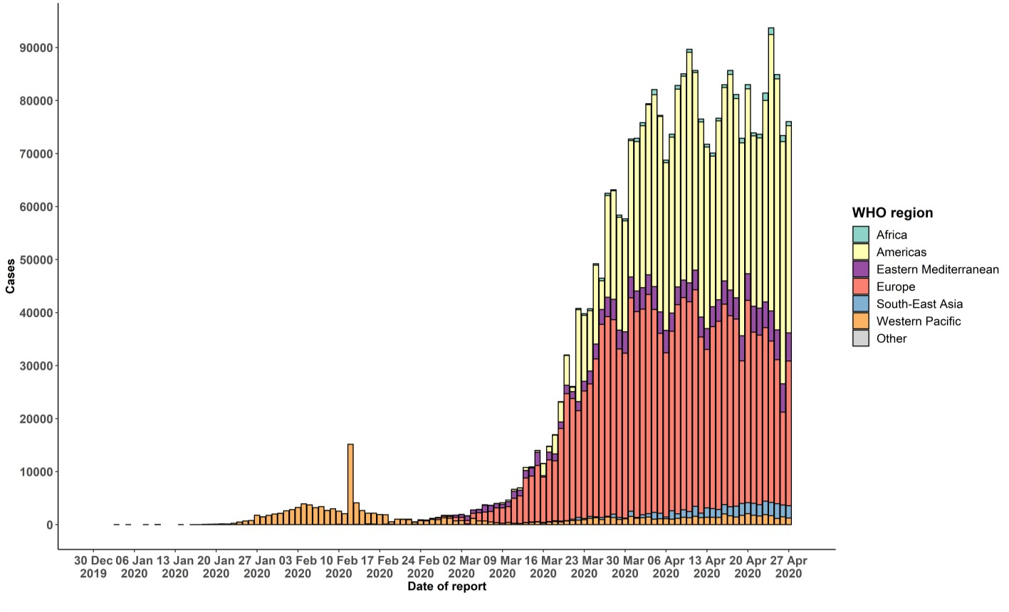

Note: Numbers in the epidemic curve have now been adjusted to reflect the data reconciliation in Spain.
STRATEGIC OBJECTIVES

WHO’s strategic objectives for this response are to:

- Interrupt human-to-human transmission including reducing secondary infections among close contacts and health care workers, preventing transmission amplification events, and preventing further international spread*;
- Identify, isolate and care for patients early, including providing optimized care for infected patients;
- Identify and reduce transmission from the animal source;
- Address crucial unknowns regarding clinical severity, extent of transmission and infection, treatment options, and accelerate the development of diagnostics, therapeutics and vaccines;
- Communicate critical risk and event information to all communities and counter misinformation;
- Minimize social and economic impact through multisectoral partnerships.

*This can be achieved through a combination of public health measures, such as rapid identification, diagnosis and management of the cases, identification and follow up of the contacts, infection prevention and control in health care settings, implementation of health measures for travelers, awareness-raising in the population and risk communication.

PREPAREDNESS AND RESPONSE
- To view all technical guidance documents regarding COVID-19, please go to this webpage.
- WHO has developed interim guidance for laboratory diagnosis, advice on the use of masks during home care and in health care settings in the context of COVID-19 outbreak, clinical management, infection prevention and control in health care settings, home care for patients with suspected novel coronavirus, risk communication and community engagement and Global Surveillance for human infection with COVID-19.
- WHO is working closely with International Air Transport Association (IATA) and have jointly developed a guidance document to provide advice to cabin crew and airport workers, based on country queries. The guidance can be found on the IATA webpage.
- WHO has been in regular and direct contact with Member States where cases have been reported. WHO is also informing other countries about the situation and providing support as requested.
- WHO is working with its networks of researchers and other experts to coordinate global work on surveillance, epidemiology, mathematical modelling, diagnostics and virology, clinical care and treatment, infection prevention and control, and risk communication. WHO has issued interim guidance for countries, which are updated regularly.
- WHO has prepared a disease commodity package that includes an essential list of biomedical equipment, medicines and supplies necessary to care for patients with COVID-19.
- WHO has provided recommendations to reduce risk of transmission from animals to humans.
- WHO has published an updated recommendations for international traffic in relation to COVID-19 outbreak .
- WHO has activated the R&D blueprint to accelerate diagnostics, vaccines, and therapeutics.
- OpenWHO is an interactive, web-based, knowledge-transfer platform offering free online courses to improve the response to health emergencies. COVID-19 resources are hosted on 2 learning channels: one for courses in official WHO languages here and a second for courses in additional national languages here.
  - There are more than 1.5 million enrolments in the platform's courses to support the COVID-19 response. Specifically, WHO has developed courses on the following topics:
  - A general introduction to emerging respiratory viruses, including novel coronaviruses (available
in Arabic, Chinese, English, French, Russian, Spanish, Bengali, Hindi, Hungarian, Indian Sign Language, Indonesian, Macedonian, Persian, Portuguese, Serbian, Turkish and Vietnamese);
  - Clinical care for Severe Acute Respiratory Infection (SARI) (available in English, French, Russian, Spanish, Indonesian, Portuguese and Vietnamese);
  - Health and safety briefing for respiratory diseases – ePROTECT (available in Arabic, Chinese, English, French, Russian, Spanish, Indonesian and Portuguese);
  - Infection Prevention and Control for COVID-19 (available
in Chinese, English, French, Russian, Spanish, Indonesian, Italian, Japanese, Macedonian, Portuguese, Ser bian and Turkish);
  - COVID-19 operational planning guidelines and partners platform to support country preparedness and response (available in Chinese, English, French, Russian, Indonesian and Portuguese);
  - SARI treatment facility design (available in Arabic, English, Italian and Portuguese);
  - An introduction to Go.Data – field data collection, chains of transmission and contact follow-up (available in English and coming soon in additional languages);
  - How to put on and remove personal protective equipment (PPE) for COVID-19 (available in English and coming soon in additional languages); and
  - Standard precautions for hand hygiene (available in English and coming soon in additional languages).
- WHO is providing guidance on early investigations, which are critical in an outbreak of a new virus. The data collected from the protocols can be used to refine recommendations for surveillance and case definitions, to characterize the key epidemiological transmission features of COVID-19, help understand spread, severity, spectrum of disease, impact on the community and to inform operational models for implementation of countermeasures such as case isolation, contact tracing and isolation. Several protocols are available here. One such protocol is for the investigation of early COVID-19 cases and contacts (the “First Few X (FFX) Cases and contact investigation protocol for 2019-novel coronavirus (2019-nCoV) infection”). The protocol is designed to gain an early understanding of the key clinical, epidemiological and virological characteristics of the first cases of COVID-19 infection detected in any individual country, to inform the development and updating of public health guidance to manage cases and reduce the potential spread and impact of infection.

RECOMMENDATIONS AND ADVICE FOR THE PUBLIC

If you are not in an area where COVID-19 is spreading or have not travelled from an area where COVID-19 is spreading or have not been in contact with an infected patient, your risk of infection is low. It is understandable that you may feel anxious about the outbreak. Get the facts from reliable sources to help you accurately determine your risks so that you can take reasonable precautions (see Frequently Asked Questions). Seek guidance from WHO, your healthcare provider, your national public health authority or your employer for accurate information on COVID-19 and whether COVID-19 is circulating where you live. It is important to be informed of the situation and take appropriate measures to protect yourself and your family (see Protection measures for everyone).

If you are in an area where there are cases of COVID-19 you need to take the risk of infection seriously. Follow the advice of WHO and guidance issued by national and local health authorities. For most people, COVID-19 infection will cause mild illness however, it can make some people very ill and, in some people, it can be fatal. Older people, and those with pre-existing medical conditions (such as cardiovascular disease, chronic respiratory disease or diabetes) are at risk for severe disease (See Protection measures for persons who are in or have recently visited (past 14 days) areas where COVID-19 is spreading).

CASE DEFINITIONS

WHO periodically updates the Global Surveillance for human infection with coronavirus disease (COVID-19) document which includes case definitions.

For easy reference, case definitions are included below.
Suspect case
- A patient with acute respiratory illness (fever and at least one sign/symptom of respiratory disease, e.g., cough, shortness of breath), AND a history of travel to or residence in a location reporting community transmission of COVID-19 disease during the 14 days prior to symptom onset.
OR
- A patient with any acute respiratory illness AND having been in contact with a confirmed or probable COVID-19 case (see definition of contact) in the last 14 days prior to symptom onset;
OR
- A patient with severe acute respiratory illness (fever and at least one sign/symptom of respiratory disease, e.g., cough, shortness of breath; AND requiring hospitalization) AND in the absence of an alternative diagnosis that fully explains the clinical presentation.

Probable case
- A suspect case for whom testing for the COVID-19 virus is inconclusive.
  - Inconclusive being the result of the test reported by the laboratory.
OR
- A suspect case for whom testing could not be performed for any reason.

Confirmed case
A person with laboratory confirmation of COVID-19 infection, irrespective of clinical signs and symptoms.
- Technical guidance for laboratory testing can be found here.

Definition of contact
A contact is a person who experienced any one of the following exposures during the 2 days before and the 14 days after the onset of symptoms of a probable or confirmed case:
- Face-to-face contact with a probable or confirmed case within 1 meter and for more than 15 minutes;
- Direct physical contact with a probable or confirmed case;
- Direct care for a patient with probable or confirmed COVID-19 disease without using proper personal protective equipment1; OR
- Other situations as indicated by local risk assessments.

Note: for confirmed asymptomatic cases, the period of contact is measured as the 2 days before through the 14 days after the date on which the sample was taken which led to confirmation.

Definition of COVID-19 death
COVID-19 death is defined for surveillance purposes as a death resulting from a clinically compatible illness in a probable or confirmed COVID-19 case, unless there is a clear alternative cause of death that cannot be related to COVID disease (e.g. trauma). There should be no period of complete recovery between the illness and death.

Further guidance for certification and classification (coding) of COVID-19 as cause of death is available here.

1 World Health Organization. Infection prevention and control during health care when COVID-19 is suspected https://www.who.int/publications-detail/infection-prevention-and-control-during-health-care-when-novel-coronavirus-(ncov)- infection-is-suspected-20200125

